**Sprint 1 - Endurance Design Document**

**March 28, 2024**

**Table of Contents**

**1.** **EXECUTIVE SUMMARY**

1.1 Project Overview

1.2 Purpose and Scope of this Specification

**2.** **PRODUCT/SERVICE DESCRIPTION**

2.1 Product Context

2.2 User Characteristics

2.3 Assumptions

2.4 Constraints

2.5 Dependencies

**3.** **REQUIREMENTS**

3.1 Functional Requirements

3.2 Security

*3.2.1* *Protection*

*3.2.2* *Authorization and Authentication*

3.3 Portability

**4.** **REQUIREMENTS CONFIRMATION/STAKEHOLDER SIGN-OFF**

**5.** **SYSTEM DESIGN**

5.1 Algorithm

5.2 System Flow

5.3 Software

5.4 Hardware

5.5 Test Plan

5.6 Task List/Gantt Chart

5.7 Staffing Plan

# 1. Executive Summary

## ***1.1*** ***Project Overview***

This project is for CS104 and is an endurance run to test the Sphero robot for both accuracy and speed in completing a loop around a rectangle. The robot must be green at start, say “ready set go”, turn, move across the blue line, stop properly at each corner, turn to the next line, and end at the origin with a red color, stating “I’m done and I need water”.

## ***1.2*** ***Purpose and Scope of this Specification***

**Intended audience**

* Computer Scientists
* Software Engineers
* Robotic Engineers
* Class of Computer Science

**In Scope**

This document addresses the parts of the Sphero Program

* User Interface
* Java program of robot
* Errors and fixes to Sphero
* Planning and roles of members involved

**Out of Scope**

This document address parts not mentioned on Project or Sphero

* Practical uses for Sphero
* System requirements
* Background information on members
* Spheros Origins
* Gives us a good idea for our future spirints

# 2. Product/Service Description

This section describes the factors that affect the Sphero product and its requirements.

* **Public Use:** Sphero is out for the general public for young audiences to gain an understanding in coding, science, music, and the arts.
* **Internet Connection**: in order to pair with the Sphero and access Sphero EDU, proper internet connection is necessary, otherwise, nothing can work.
* **Activities:** Sphero has many activities for people of all ages through Sphero Edu app and littleBits Classroom. Challenges can be completed through STEAM as well.
* **Room Availability:** We had to be able to adapt to the times that the room was being used.

## ***2.1*** ***Product Context***

The device used, Sphero Sprk, is a part of a broader system of different Sphero robots. The other robots include, the Sphero Bolt, Sphero Mini, Sphero RVR+, Sphero Indi, and many more. All of these robots are connected through the same program, Sphero EDU, where types of Spheros can be paired and coded.

## ***2.2*** ***User Characteristics***

This section describes the scope of the users.

* Students: Students will have little to no prior experience in Sphero and will use challenge activities to help them learn on the Sphero EDU app. Many tests and understanding of code will be gained through application problems. Student range however is just as broad when the learning curve of Sphero is understood.
* Professor: The Professor will have much more insight on Sphero and its capabilities. He or she will be able to assist others in learning Sphero and can possibly gain insight as well from teaching.
* Staff: Staff members overseeing the product will have more insight than students but potentially less insight in the functionality of Sphero than the professor. As the staff work through the project they will be able to understand the product more.

## ***2.3*** ***Assumptions***

* Sphero charged: It is assumed that the Sphero is properly charged, it will take longer to do the testing and coding phase if not and charging will be required.
* Sphero EDU program: It is assumed that the Sphero EDU program should run properly but flaws or bugs are still plausible. This can affect the testing and coding phase, as well as the overall performance in the endurance run. Multiple tests may be needed to perform and record a video that is fit for the requirements of the project.
* Phone and Computer availability: It is assumed that phones and computers will be available at all times. If either were broken or dead, the project would not be able to be completed in any aspect for planning, testing, coding, or videotaping.

## ***2.4*** ***Constraints***

* Sphero availability: Only one member of the group is able to have the Sphero at the same time. If one member has it while being unavailable, the other members can not perform tests.
* If the security of the system is breached the program may be compromised and setbacks will occur due to privacy and protection.
* System resource constraints: Computers may not have enough storage to download the necessary Sphero EDU app. This will result in delays.
* Sphero mapping and consistency: Sphero is known to have faulty mapping in terms of its direction and turning. Sometimes turning is factored into the time and slows down the overall process.

## ***2.5*** ***Dependencies***

Dependencies are what the program relies on to function

* For the system to run, the algorithm and the flow chart must be designed for a full plan
* Sphero will require either a computer or phone to run the program

# 3. Requirements

There are a few requirements that we must meet for this project to successfully run. First, we must start on the yellow tiles in the corner of the front room, and the robot must be lit up green (priority level 1). Then the robot must speak “Ready, Set, Go” before any movement takes place (priority level 1). Next the robot must go around the room in a rectangular shape in accordance with the blue tape on the floor (priority level 1 or 2). When it has completed the sprint, the robot then must say “I am done and I need water,” while also changing its color from green to red (priority level 1).

## ***3.1*** ***Functional Requirements***

| **Req#** | **Requirement** | **Comments** | **Priority** | **Date Rvwd** | **SME Reviewed / Approved** |
| --- | --- | --- | --- | --- | --- |
| ENDUR_01 | Robot starts in first square and is set to green |  | 1 | 3/20 | Approved |
| ENDUR_02 | Robot says “Ready Set Go” |  | 1 | 3/20 | Approved |
| ENDUR_03 | Robot must proceed over the blue line and stop at the first corner |  | 1 | 3/20 | Approved |
| ENDUR_04 | Robot must turn facing the perpendicular blue line |  | 1 | 3/20 | Approved |
| ENDUR_05 | Robot must proceed over the second blue line to the second corner |  | 1 | 3/20 | Approved |
| ENDUR_06 | Robot must turn facing the next perpendicular blue line |  | 1 | 3/20 | Approved |
| ENDUR_07 | Robot must proceed over the third blue line to the third corner |  | 1 | 3/20 | Approved |
| ENDUR_08 | Robot turn to the next perpendicular blue line |  | 1 | 3/20 | Approved |
| ENDUR_09 | Robot proceeds on the 4th blue line ending at the original start |  | 1 | 3/20 | Approved |
| ENDUR_10 | Robot says “I’m done and I need water” |  |  |  | Approved |
| ENDUR_11 | Robot turns red |  | 1 | 3/20 | Approved |

## ***3.2*** ***Security***

### **3.2.1** **Protection**

There are many factors that protect the system from malicious or accidental access, modification, disclosure, destruction, or misuse.

* **Data protection and encryption**: All data is password protected and accounts are stored in a secure user database accessible only by administrators to Sphero EDU.
* **Privacy Policy**: No data is used for advertising. Data is only stored for app analytics. First and last names are optional .Sphero EDU does not use any cookies for marketing, tracking, or analytics purposes.
* **Age restrictions**: Users under 13 need parental permission to access Sphero EDU, children otherwise can not access Sphero EDU.
* **Data integrity checks**: Are implemented to maintain that everyone working on the program states who they are, what they add, and when. This ensures that no major errors are made, or at the very least are identifiable. It also ensures that the proper staff are working on the project and no malicious third party.

### **3.2.2** **Authorization and Authentication**

* When the project started, we were given Authorization by Professor Eckert to take the robot by signing it off.
* Github requires a sign before placing anything into the repository.

## ***3.3*** ***Portability***

* **Host Dependent Code:** The code we do in SpheroEDU is 100% host dependent, but the app can be on every single device..
* Our laptops are portable
* Our Sphero Robot is portable
* Code is only shared via GitHUB and pictures through iMessage
* The product works the same regardless of operating systems and devices with the same code.

# 4. Requirements Confirmation/Stakeholder sign-off

| **Meeting Date** | **Attendees (name and role)** | **Comments** |
| --- | --- | --- |
| 03/27/2024 | Anthony S, Kooper K, Esha A | Discussed final design document roles, in addition to recording the video of the code implemented for sprint 1. |

# 5. System Design

This section provides all of the details concerning the design and process of how the endurance sprint program was created. It gives a sequence of the planning, algorithm, software, system flowchart, hardware, test plan, gantt chart, and staffing plan. All of these were developed and would not be possible if they had not been properly merged together.

## ***5.1*** ***Algorithm***

This Algorithm is designed in terms of pseudocode on how the overall actual program will turn out. It suggests the speeds and time as x, as it is unknown how fast and for how long it will take before actual tests.

* 1. Robot starts at origin facing 0 degrees/forward
* 2. Turn Main LED to green
* 2. Outputs “Ready. Set. Go”
* 3. Goes over line 1 at x speed and stops end end point 1
* 4. Stops for 2 seconds
* 5. Turns 90 degrees right, goes over line 2 at x speed and stops at end point 2
* 6. Stops for 2 seconds
* 7. Turns 90 degrees right, goes over line 3 at x speed and stops at end point 3
* 8. Stops for 2 seconds
* 9. Turns 90 degrees right, goes over line 4 at x speed and stops at origin
* 10. Stops for 2 seconds.
* 11. Speak “I’m done and I need water.”
* 12. Robot turns red.

## ***5.2*** ***System Flow***

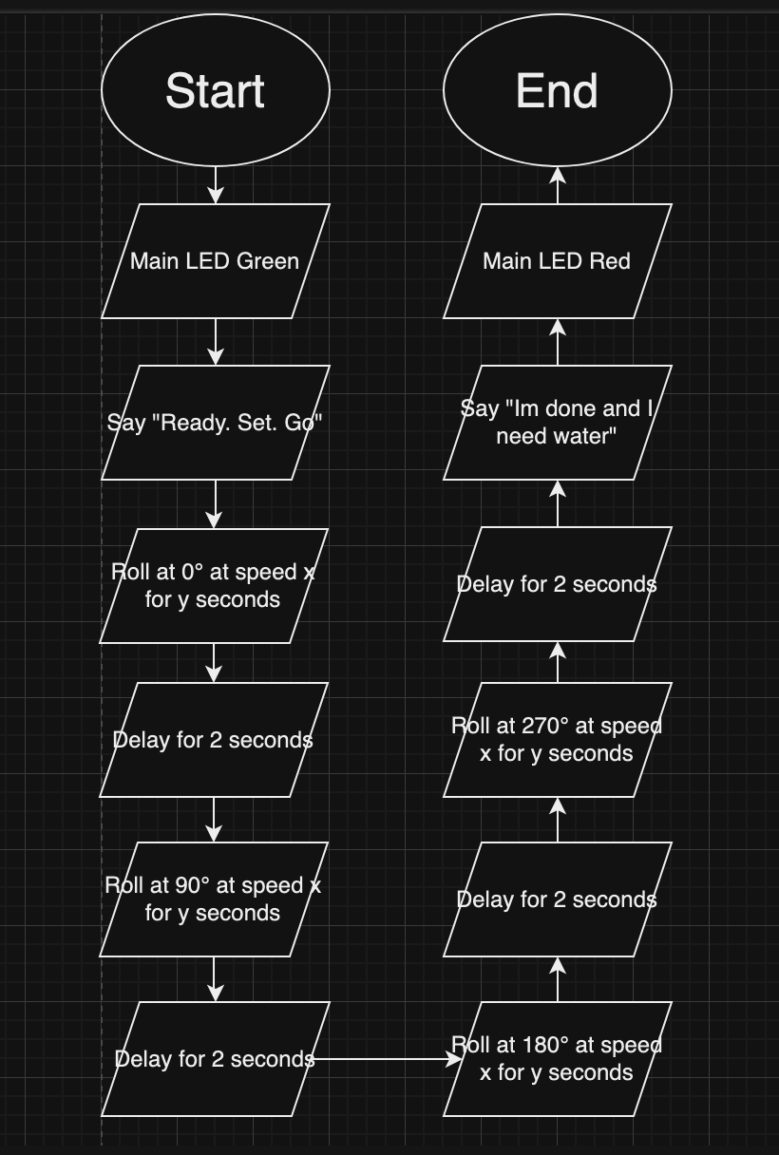

## ***5.3*** ***Software***

* SpheroEDU is the coding language we used to program the output and performance for this sprint.
* We used Github to upload our system design document along with our video of the sprint.

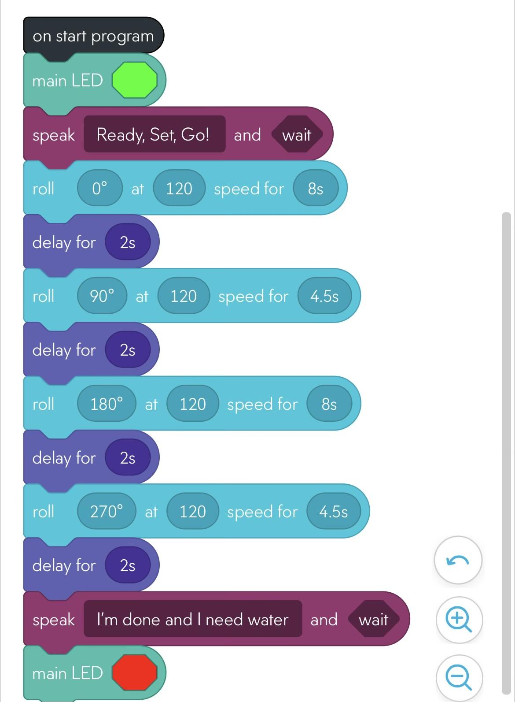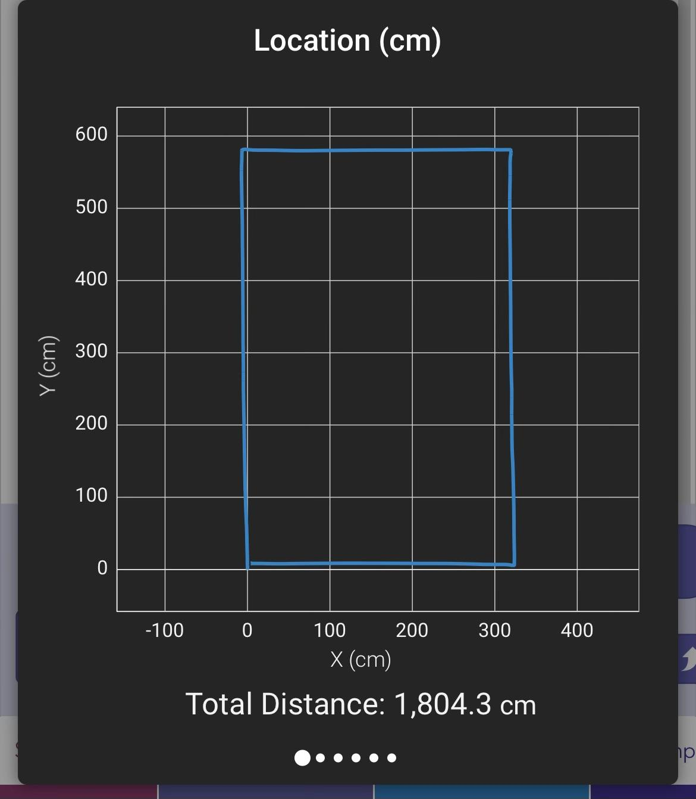

## ***5.4*** ***Hardware***

* A Macbook and Iphone’s were used for designing, testing, and running the program. Also speaks when the robot says “Ready. Set. Go”, and “I’m done and I need water.”
* SPRK Robot: Used in the endurance run. Moves around the space to complete the trial. Turns red and green in the experiment
* Blue tape: the pathway of where the SPRK Robot should follow upon.

## ***5.5*** ***Test Plan***

| **Reason for Test Case** | **Test Date** | **Expected Output** | **Observed Output** | **Staff Name** | **Pass/Fail** |
| --- | --- | --- | --- | --- | --- |
| Robot turns, moving across line 1 and stopping | 3/20 | Stops at end 1 | Rolled the opposite direction | Kooper | Fail |
| Robot turns, moving across line 1 and stopping | 3/20 | Stops at end point 1 | Rolled on an angle and not far enough | Kooper | Fail |
| Robot turns, moving across line 1 and stopping | 3/20 | Stops at end point 1 | Stopped a little short | Kooper | Fail |
| Robot turns, moving across line 1 and stopping | 3/20 | Stops at end point 1 | Finally stopped at end point | Kooper | Pass |
| Robot turns, moves across line 2 and stops at end point 2 | 3/20 | Stops at end point 2 | Stopped a little over to the right of endpoint 2 | Kooper | Fail |
| Robot turns, moves across line 2 and stops at end point 2 | 3/20 | Stops at end point 2 | Stops on end point 2 | Kooper | Pass |
| Robot turns, moves across line 3 and stops at endpoint 3 | 3/20 | Stops at endpoint 3 | Stopped at end point 3 | Kooper | Pass |
| Robot turns, moves across line 4, ends at the starting point and turns red | 3/20 | Stops at start point and turns red | Stopped at start point and did not turned red (stayed green) | Kooper | Fail |
| Robot turns, moves across line 4, ends at the starting point and turns red | 3/20 | Stops at start point and turns red | Stopped at start point and turned red | Kooper | Pass |

## ***5.6*** ***Task List/Gantt Chart***

## 

## ***5.7*** ***Staffing Plan***

| Name | Role | Responsibility | Reports To |
| --- | --- | --- | --- |
| Kooper K | Project Supervisor | Divides roles, works on all aspects of the project. Oversees progress of the project. | Prof. Eckert |
| Esha A | Project Editor | Edits the final SDD and make sure the project is structured properly. | Prof. Eckert, Kooper K, Anthony S |
| Anthony S | Management and editor | Edits the final SDD, tests the robot and get video for gitHUB repository. | Prof. Eckert |